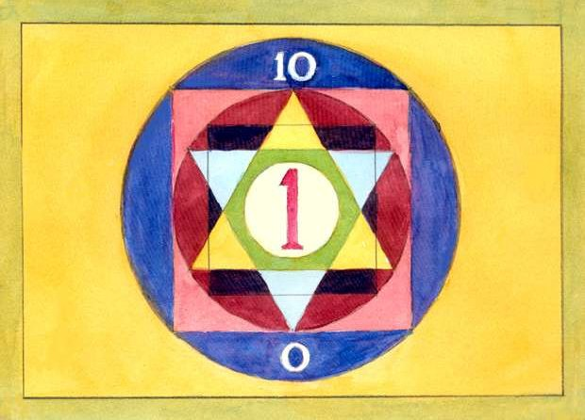

THE ORDER IN CREATION IN NUMBER AND GEOMETRY

Tontyn Hopman

www.adhikara.com/tontyn-hopman-number-and-geometry

Illustrations by the author

About the origin of “The Order in Creation in Number and Geometry”.

The author, Frederik (Tontyn) Hopman, was born in Holland in 1914, where he
studied to become an architect. At the age of 18, after the death of his father, he had a
powerful experience that led to his subsequent study of Oriental esoteric teachings. This was to become a life- long fascination. Responding to the call of the East, at the age of 21, he travelled to India by car. In those days this adventurous journey took many weeks. Once in India he married his travelling companion and settled down in Kashmir, where he lived with his young family for 12 years until in 1947 the invasion from Pakistan forced them to flee.
Still in Asia, at the age of 38, Tontyn Hopman had a profound Kundalini awakening
that gave his life a new dimension. It was during this awakening that he had a vision of Genesis, which revealed to him the ‘Order in Creation in Number and Geometry’. Around this time, however, Tontyn Hopman decided to return to Europe to enable his children to have a good education and he settled in Switzerland to practise his profession as an architect. Later he occupied himself with astrology and art therapy. Here, in Switzerland, after almost half a century, the memory of his vision came up again, with great clarity. Tontyn Hopman experienced a strong impulse to work on, and present the images that had been dormant for such a long time to the wider public. Fina lly, out of this, in the year 2000, ‘The Order in Creation in Number and
Geometry’ emerged, in only a few months.

ACKNOWLEGEMENT BY THE AUTHOR

I would like to thank herewith, all those friends and acquaintances, who in various ways, contributed to the realisation of this work; ‘The Order in Creation in Number and Geometry’.
In particular I am very much indebted to Vincenzo Altepost who encouraged me to initiate and finalise this contribution and prepare to put it on the Internet.
www.adhikara.com/tontyn-hopman-number-and-geometry
Mark Webster, for checking and improving my English. Monika Young, for her very dedicated contribution of putting the text in order and transferring it to a disk.

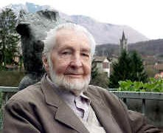

Tontyn Frederik Jan Hopman
c/o Rhea Quien
rhea@rq-art.com
www.rq-art.com

CONTENTS

Fig. Page
1 VISIONS OF PRIMAL UNITY (ONE) 1 6
➢ ➢ | Visions of Axiomata  Experienced as Axiomata.
➢  ➢ | Realisation of Nothingness (0).  Principles.
2 | DUALITY | 2 | 8
➢ ➢ ➢ | The Split Caused by Consciousness. Potency of the Zero.  Reflection and Duality.
➢ ➢ | Reflection and Philosophy of Life. Principles.
3  ➢ | ENERGY FORMS AS DIFFERENTIATION OF DUALITY Being and Doing as Basis of Existence. | 3 | 10
➢ ➢ | Significance for the Creation. Principles.
4  ➢ | UNIFICATION  Mutation Versus Evolution. | 4 | 11
➢ | Principles.
5  ➢ ➢ | THE EMERGENCE OF CREATIVITY The birth of the New in Creation. Principles. | 5 | 12
6 | THE MUTATION OF THE TRIANGLE | 6 | 13
➢ ➢ ➢ | Origin of the First Surface.  The Solitary Point of Relationship at the Apex. Indian Symbolism of the Triad.
➢ ➢ | The Meaning of the Sides of the Triangle. Principles.
7  ➢ | AN EXAMPLE OF MUTATION Arising Out of Nothing. | 7 | 15
➢ ➢ | Principle.  The Stages of Mutation. | 7A-E | 16-20
8  ➢ | THE SQUARE Analysis of its Parts. | 8 | 21
➢ | Qualities of the Numbers.
9  ➢ ➢ | THE SQUARE, SYMBOL OF THE EARTH  The Square and its Correspondences to the Earth. Concept of Directions of the Earth and their Symbolic | 9 | 23
➢ | Significance.  Orientation of the Earth.
➢ | Principles.

10 THE DYNAMISM OF THE SQUARE 10 25
➢ Hidden energy of the square.
➢ Principle.

11 THE GOLDEN SECTION 11 26
➢ Construction.
➢ Symbolic Values.
➢ Example of the Unity of Construction.
➢ Principles.

12 THE SPIRAL IN THE GOLDEN SECTION 12 27
➢ Every Sacred Presentation Contains the Aesthetic.

13 THE MEASURES OF THE PENTAGRAM IN THE
GOLDEN SECTION 13 28
➢ The Construction of a Unique Figure

14 THE PENTAGRAM AS A SYMBOL OF
SPIRITUALISATION  ➢ Analysis of its Composition. | 14 | 29
➢ The Symbolic Meaning of the Pentagram.
➢ The Sacred Centre.
➢ Concepts from the ‘Middle Ages’.
15 ANOTHER FORM OF THE PENTAGRAM  ➢ Significance.  ➢ Principles. | 15 | 31
16 THE CONSTRUCTION OF THE CIRCLE | 16 | 32
➢ How Geometry Can Depict Creation.
➢ The Circle and the Emergence of the Hexagram.
➢ The Circle of Opposites.
➢ The Ancient Gods Characterise the Points of the Hexagram.
➢ Principle.
17 IN THE HEXAGRAM THERE IS UNITY OF DUALITY  ➢ The Complexity of Operating Influences. | 17 | 34
➢ Cosmic Influences Shown Geometrically.
➢ Principle.
18 THE HEPTAGRAM  ➢ Contemplating the Composition. | 18 | 36
➢ Principles.
19 THE OCTAGRAM  ➢ A Picture of Contrast.  ➢ Composition of the Basic Influences. | 19 | 38
➢ Principles.

20 THE NONAGRAM  ➢ The Process of Unification is Accomplished. | 20 | 40
➢ What this Means for the Quality of Life.
➢ Principles.
21 THE ONE MEANS TOTALITY | 21 | 42
➢ The Return to the Primal ONE.
➢ Esoteric Mathematics.
➢ Principles.

1.VISIONS OF PRIMAL UNITY (ONE) Fig. 1
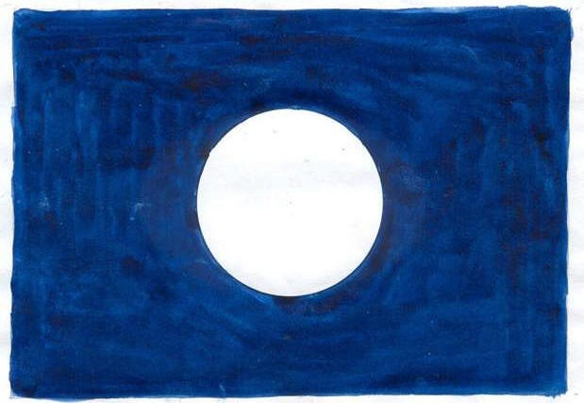

Visions of Axiomata

I see a shrinking disc in midnight blue. Intuition tells me that it is the ONE in state of Being and the IDEA of everything is potentially contained therein in a totally abstract state.

This PRIMAL CONSCIOUSNESS is in complete equilibrium. This infinite Circle has no centre but every entity is endowed with the divine ONE as centre. All is centre. Nothing is limitation.

Experienced as Axiomata

CONSCIOUSNESS of UNITY is LOVE. CONSCIOUSNESS of BEING is heavenly BLISS. UNITY of BEING is COSMOS.
LIGHT of CONSCIOUSNESS is INTELLIGENCE. LIGHT of UNITY radiates in ETERNITY.
IN all life the LIGHT of BEING shines.

In this BEING, who is total, awareness arises that nothing (0) is something. Because of this the idea of Duality (2) arises. The entire Creation evolves from the ONE and the Zero as well as all numbers, one or the plurality of one, and every unity: Cosmos, world, man, animal, plant and electron.

In the beginning there is only the PRIMAL ONE as a point of Light, without dimension. In this point an impulse to expand arises, creating the first dimension, presenting itself as a line. Out of this line evolves the radius of the Circle of EXISTENCE, thus creating the second dimension.

Realisation of nothingness (0)

By itself Zero is nothing but has potency. This potency can be experienced in the midnight sky, in the deep blue between the stars, in the empty spaces in Chinese art, in the interval between music notes, in the call to pray of the Muezzin from his Minaret, in the inner silence of meditation.

PRINCIPLES: DUALITY, POTENCY

2.DUALITY Fig. 2

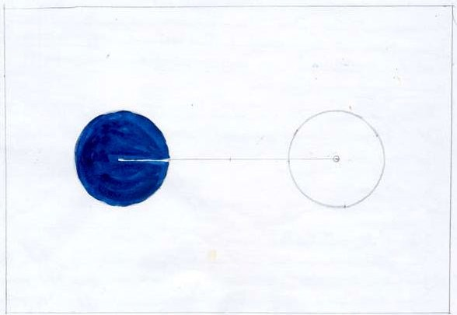

The Split Caused by Consciousness

The Consciousness of the ONE, realising that nothing is something causes duality. This duality arises from: firstly the One (1), secondly from the Zero (0).

Potency of the Zero

The zero has potency. This power is activated by the projection of the ONE. It is because of this, that it unfolds its capacity of reflection. Itself, however, is not that which it reflects. Just as a mirror reflects, but itself is not the source of light.

From an energy point of view, the light unit radiates in the dark one. Thereby the radiation is reflected and forms the principle of REFLECTION. Hereby the reflecting unit remains neutral.

Reflection and Duality

Reflection is made possible from the limitation of the surface of the second unit, (2).

Duality consists of the principles of both light and dark, of the conscious and the unconscious, of being and of non-being (nought), as well as the principles of AMBIVALENCE and ILLUSION. Similarly of energy and inertness.

In order to illustrate this, we take two units (Fig. 2), one of which is shown as a light, the other as a dark Circle. From this two things can be realised: the limitation of the Circle causes a CENTRE and the connection of both Circles to each other causes the principle of RELATING. The principle of duality is caused by mutation of dimensionless infinity to the differentiated finiteness.

The light unit radiates and the dark reflects. To illustrate this, here is an example taken from the heavenly bodies. When we, by full moon, assert that this light is strong, we succumb to an illusion. The moon does not radiate light. The source of the light is the sun.

In Fig. 2, the dark unit has the potency to reflect what the light one radiates. We are subject to an illusion when we attribute absolute reality to the world we live in. It has been scientifically proven that matter is predominantly empty space wherein energy sporadically moves.

Reflection and Philosophy of Life

The absolute reality exists only as abstract ideas in the ONE. The ambivalence and abstract nature of the dark unit emanates reflections of abstract images held in the totality of the ONE. The recognition of this can have a special influence on our philosophy of life.

This relative reality of the dark unity exists simultaneously with the absolute reality. We are occasionally aware that we live in this. The ONE is the foundation of the creation of all life and supreme wisdom.

In creation duality only has relative reality, but because of the presence of the
PRIMAL ONE in every entity there exists a tendency to UNITY.

PRINCIPLES: UNIFICATION, AMBIVALENCE, REFLECTION.

3.ENERGY FORMS AS DIFFERENTIATION OF DUALITY Fig. 3

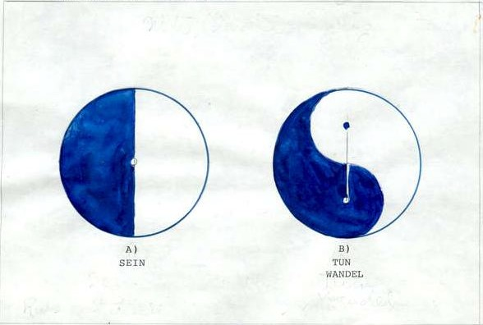

Being and Doing as Basis of Existence

Two units of duality are being conjoined by the principle of Unification. Two possibilities to accomplish this emerge:

a) By halving their individual centres. This forms a STATIC union that refers to the
ONE, because both sections now have a common centre.
or
b) By halving their limitations. This gives rise to a DYNAMIC union that produces
ROTATION (Fig. 3b). This dynamic alternative relates to the Two because each half has its centre. Due to the tension of unification between the two centres rotation is activated.

Significance for the Creation

The dark half represents zero. Because of its potency it can increase or reduce the qualities from light to dark. It can cause the state of Being to expand to the totality of the primal ONE, or reduce it to a minimal existence.
Fig. 3b. is like the East Asian Tai Gi. This is a rhythmic, sinus shaped representation
of the Energy of LIFE. In living beings it is the beating of the heart, the breath, the rhythm of the digestion, of sleeping and waking. It is also nature manifesting as the alternations of the seasons, day and night, the motion of waves in water, the movement of the celestial bodies, and in the earth as the precession of the equinoxes, and electromagnetic radiatio n.

PRINCIPLES: STATIC, DYNAMIC, ROTATION, LIFE- ENERGY.

4.UNIFICATION Fig. 4

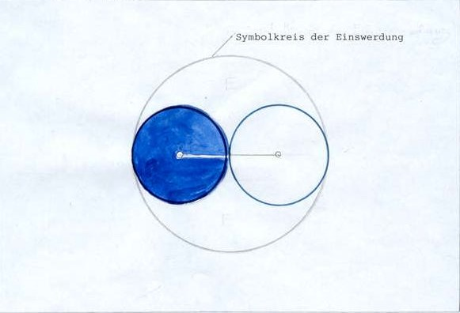

Mutation Versus Evolution

Inherent in the creation by the primal ONE exists the energy of Unification, the impulse to return to the source. This does not happen because of evolution – as, at this stage time does not exist. Rather, it is catalysed by mutation. This tendency can be portrayed as a large Circle encompassing the smaller ones forming duality. These Circles touch each other only at one point, which is simultaneously the centre of the uniting energy. This, however, means a double limitation, or in other words a limitation of limitation, which means an OPENING in the border lines.

The line of relation between the two units depicts the energy of unification.

PRINCIPLES: OPENING, MUTATION.

5.THE EMERGENCE OF CREATIVITY Fig. 5

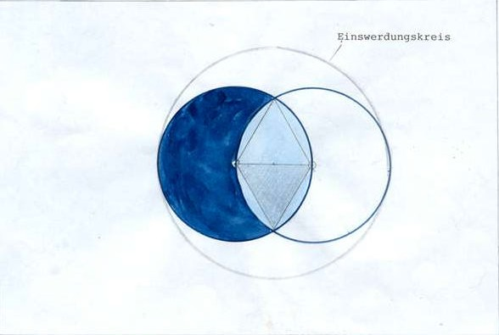

The Birth of the New in Creation

Because the limitation between both units has been removed a Mutation results.

Due to this overlapping of the circles a MANDALA appears. Therefore the area and shape of the Mandala symbolises the principle of the NEW.

Within the area of unification lies the CREATION of the TRIANGLE, which results from drawing lines between the centres of both Circles and to that exceptional point where both circles cross each other.

According to the principles of reflection, the lower Triangle is the reflected image of the upper one.

Between the two unit centres there is the tension of unification.

PRINCIPLES: THE NEW, BASIS, MANDALA, TRIANGLE.

6.THE MUTATION OF THE TRIANGLE Fig. 6

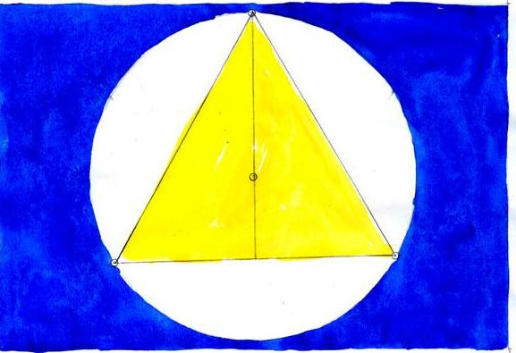

Origin of the First Surface

This results from the relationship between the Circle and its radius. The equilateral Triangle constructed within a Circle shows the geometrical instance where limitation and line of a relationship form a unit.

The structure of the Triangle results from those sectors of the Circle that have the same length as their radius. This division is exact. Circle and Triangle have a joint centre, as is the case in the following figures.

The Triangle is the first plain surface formed by lines of relationship, in accordance with the principle of DIFFERENTIATION (which is a property of the Triangle), thus giving rise to MULTIPLICITY. Multiplicity is clearly demonstrated by the triangular prism, which divides white light into seven colours.

The Triangle has three angles and the difference between these is that the superior one is elevated and the lower angles, together, form the base. Between these there is duality. The plain surface defined by the sides has the quality of
COMMUNICATION because it is enclosed by lines of relationship. The point where these lines cross has a special significance.

The Solitary Point of Relationship at the Apex

This superior angle that is related to unity and the silence of the ONE, is that point where the duality of the lower angles, when united through mutation with it, find they can harmonise their conflict and tension. The lateral sides, therefore, represent the

quality of unification. The upper angle is elevated above the two others and has objectivity and a superior position. Thereby a union of the two lower ones becomes possible.

It also means unity in opposition to duality. The figure now suggests the principles: VERTICAL and HORIZONTAL as well as HIEGHT and WIDTH.

Indian Symbolism of the Triad

In Hinduism one has the concept of the so-called Gunas, as primal different iation of the energies of creation and attributes.

They comprise the spiritual Sattva, the light principle of the universe, cause of all higher spiritual impulses, harmony and purity, and belonging to the level of Being. Then, Rajas, glowing substance, cause of all activity and passion. Thirdly Tamas, visualised as dullness, laziness and heaviness as well as darkness.

The Meaning of the Sides of the Triangle

In the Triangle the concepts allied to the differentiation of RIGHT and LEFT become apparent, with the help of linguistic usage: left in Italian is ‘sinistra’. This corresponds with the English word ‘sinister’, meaning dark, uncanny, gloomy and left.

In contrast the right angle has the meaning of clarity, light, dynamism, activity and aggression. This comes close to the equivalent of the Indian Gunas.

Because of the equal lengths of its sides, the equilateral Triangle presents an image of
HARMONY.

PRINCIPLES: VERTICAL, HORIZONTAL, HEIGHT, WIDTH, HARMONY, COMMUNICATION.

7.AN EXAMPLE OF MUTATION Fig. 7

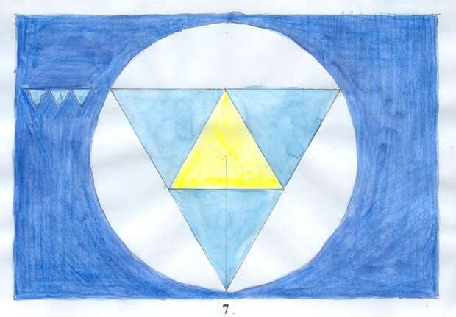

Arising Out of Nothing

When three Triangles of the same size are put together and arranged to form a unit, the result is four identical Triangles. The fourth is in a position of INVERSION: in fact, the forth results from the unity of the three.

Mutation of the new arises where entities are forming unity. An example of this is the appearance of a Mandala in Fig. 5, because of the poles of duality uniting.

PRINCIPLE: INVERSION

The Stages of Mutation Figs. 7A – 7E

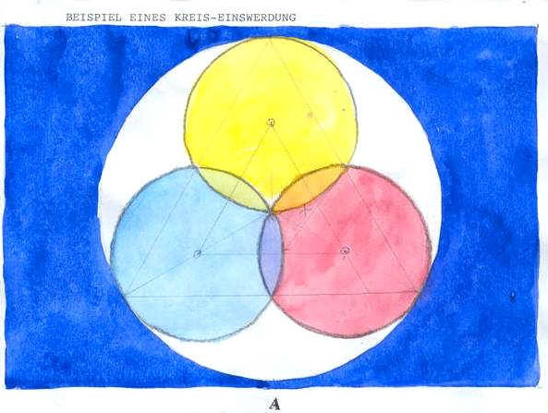

Whe reas straight lines and the figures composed therein depict relationship and differentiation, the Circle denotes unification.

Fig. A has been constructed in such a way that the Circles’ centre is situated exactly in half the radius of the circumference and their over- lapping results in the three Mandalas. Mandalas symbolise creativity and the NEW. Starting from the points of the Mandalas, the distance X is visible, indicating the subsequent stages of mutation.

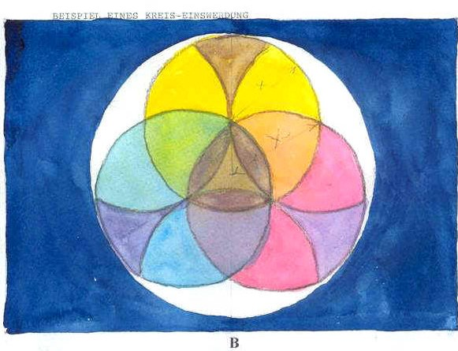

In Fig. B, the centre of the three Circles move together, resulting in an expansion of the Circles. The distance of the point of the Mandala, to the centre of the circumference is called Y. The distance X in Fig. A becomes the radius of the three inner Circles. This results in six Mandalas and three Calyxes. The latter show a process of growth from the middles of the Circle towards the circumference.

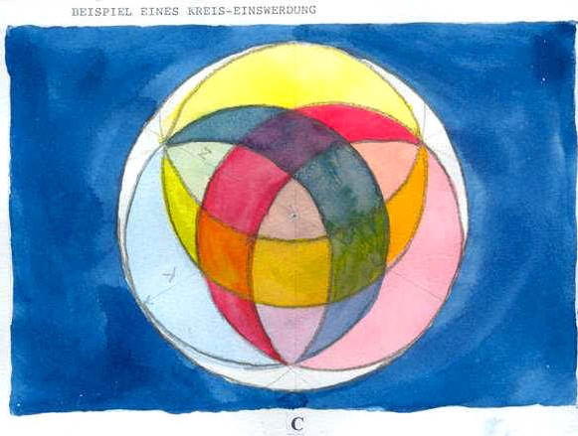

Equally, Fig. C represents the distance between the centre of the circumference and the intersection of the smaller Circles, whereas Y, in fig. B, becomes the radius of the three inner Circles. Together they form three half- moon shaped sections which overlap each other, touch each other at their points, and so, constitute unity.

If compared to the moon in the sky, the crescent moons and their compliments within each Circle, form a luminous, reflecting, and dark absorbing section.

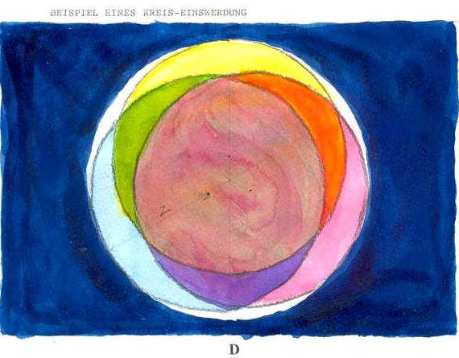

In the case of Fig. D, the distance Z in Fig. C, to the radius of the three inner Circles, mutates into an extension of the central area, which approaches ever more the circumference.

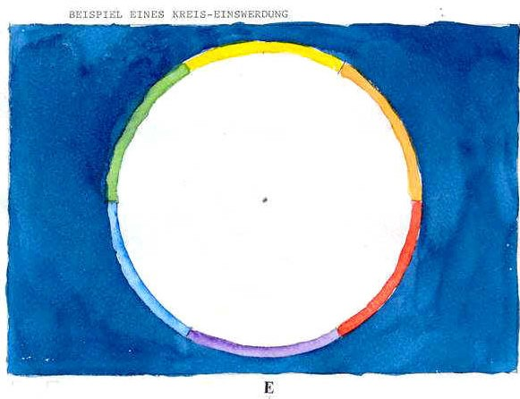

Fig. E shows the culmination of the stages of mutation. When the three inner Circles have become completely one with the circumference, this is being enriched by their individual qualities that develop out of the previous stages of development of mutation.

8.THE SQUARE Fig. 8

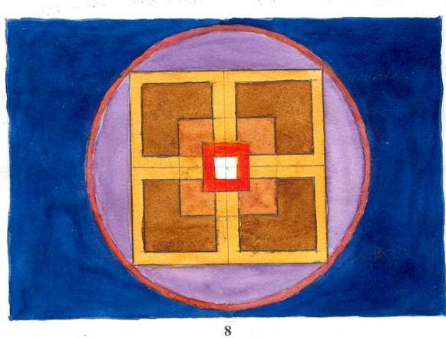

Analysis of its Parts

In order to understand which qualities of the primal ONE are generated in the following figures, it is helpful to examine which influences of the preceding numbers are contained therein.

The Square is f. i. the sum of 1+3, both odd numbers. This can be depicted as a dot in the middle of a Triangle. This figure has the quality of the splitting up into parts of pluralities or relationships. But through the ONE (the dot), the quality of harmony is brought out and the splitting up is prevented.

From another point of view there is 2+2, meaning two dualities. Of these the upper one relates to light and dark or reality and illusion. The lower duality causes a split between subject and object and therefore leads to conflict. It also suggests the breaking up into pairs of opposites: good/bad, right/left etc.

The four not only consists of 2+2, but also of 2x2, which therefore heightens the negative qualities.

Qualities of the Numbers

In number symbolism, the uneven numbers 3, 5, 7, 9 are regarded as active and positive. The even numbers 2, 4, 6, 8 are negative and passive. All the even numbers

consist of two and its multiples. The negative evaluation is caused by the duality with its tensions, aggressions, deceptions and tendency to attach to matter.

The uneven numbers are more related to the primal ONE, because of the positive qualities of these numbers: (3) harmony and intelligence, (5) love and art, (7) spiritualisation, (9) impulse to reunion. The numbers 2 to 4 refer more to the elements of creation, those of 5 to 9 to the influence of the spirit therein.

9.THE SQUARE, SYMBOL OF THE EARTH

Matter is a projection of the primal ONE on the Zero and consists of empty space wherein ITS energy is sporadically manifest. Therefore it is a projection on the world of duality and is manifest next to UNITY. Matter is originated where the static and dynamic elements of duality integrate.

The Square represents matter and concrete REALITY. TIME is created simultaneously. This time is dual as past and future and not present in the NOW. The present is eternal and related to the ONE.

The Square and its Correspondences to the Earth

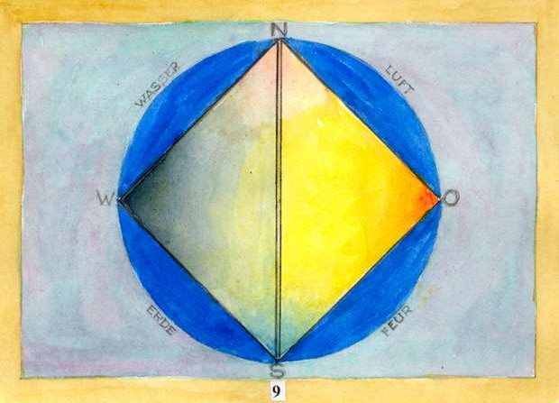

The Square is a symbol of the earth, as the Triangle is of the Spirit.

The previously described static and dynamic forms of energy are also subject to the effect of Unification.

With the projection of the Circle into the third dimension, the sphere emerges. The axis thereof is, theoretically, still and is an image of the Primal ONE. The earth itself is a centre of GRAVITATION, which, according to the principle of Unification, draws everything to it. According to the law of dua lity, there is a second axis of dynamic magnetic energy that can be even a hundred kilometres from the geocentric axis.

The North South axis is stable, but the East West one is dynamically rotating.

Concept of Directions of the Earth and their Symbolic Significance

The related manifestations are North South: summer and winter, and East West: day and night. From our North pole positive magnetism flows southward. The poles are related in a complimentary manner like Yin and Yang and the South pole is actually the colder. The geographical axis is one, and still. The East West axis corresponds to a rotating globe in SPACE and TIME.

Our concept of time originated from this double rotation of the earth: around its own axis and around the sun.

The East reminds us of sunrise, the awakening and ascending of the light and growing temperatures. Connected to this is a certain sacred evaluation because of the sun, always having been regarded as a source of Divine Light, is associated with the
Primal ONE and Life itself. Contrary to this, the West is related to weakening and
setting of the source of light: of darkness and dying.

Life is the manifestation of the Primal ONE into matter; death is the absence of the same when it is withdrawn from matter.

Orientation of the Earth

Magnetism is created by the rotation of the earth, which also is the cause of centrifugal forces. Our concepts of vertical and horizontal refer respectively to the centre of the earth and the surface. Verticality occurs in one direction, that to the centre of the earth and to its surface. Horizontality has innumerable directions.

The sides of the Square have their own symbolism that corresponds to the esoteric elements. The basis obviously belongs to the solid earth, the upper side to the
element of earth. The left vertical side corresponds to water and the feminine, and the right side to male and fire. When considering the oriental concept of five elements, ether is in the centre.

PRINCIPLES : SPACE, TIME, MATTER, NORTH, SOUTH, EAST, WEST, POLE, MAGNETISM, LIFE, DEATH, REALITY.

10.THE DYNAMISM OF THE SQUARE Fig. 10

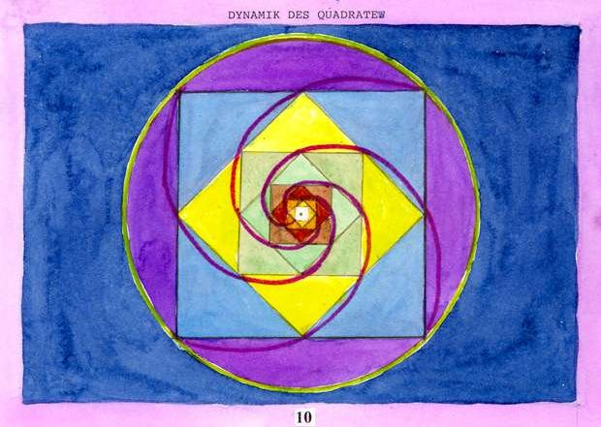

Hidden Energy of the Square

The number four is exceptional in that it is both product and addition of the number two: 2 x 2 = 4 and 2 + 2 = 4. Hereby its duality is emphasised.

Likewise the four has a double function of stability and dynamism. The earth demonstrates this dynamism in its rotation and still axis and in its solar axis when rotating around the sun. Fig. 10 demonstrates how, when two Squares, standing and sitting, are constructed inside each other, a SPIRAL is drawn touching the corners of each subsequent smaller or larger angle.

PRINCIPLE: SPIRAL

11.THE GOLDEN SECTION Fig. 11

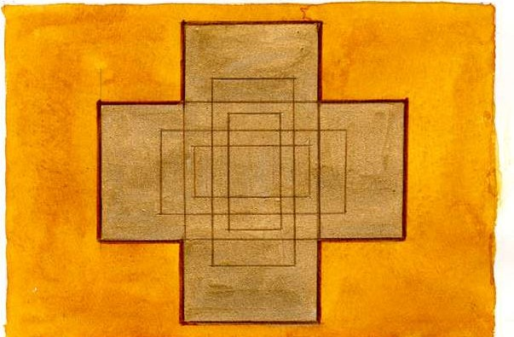

Construction

The Golden Section was already known in Pythagoras’ times. It is UNIQUE in that no other constructed figure has its qualities.

Construction: from the middle of the side of a square draw diagonal AB to the
opposite corner, from their draw an arc that defines the length of a rectangle CF which has the dimensions of a Golden Section. Then construct the square HG which is part
of the Golden Section HF. Now we have the analogous proportions CE : EF = EF : BF. These proportions can be repeated, as larger or smaller rectangles into INFINITY.

Symbolic Values

So, here, infinity and Uniqueness are combined and endow the Golden Section with its SACRED status.

Example of the Unity of Construction

The above composition of 12 Golden Section rectangles has been constructed on the basis that the length of the smaller figure always defines the width of the larger one.

PRINCIPLES : UNIQUE, INFINITE, SACRED.

12.THE SPIRAL IN THE GOLDEN SECTION Fig. 12

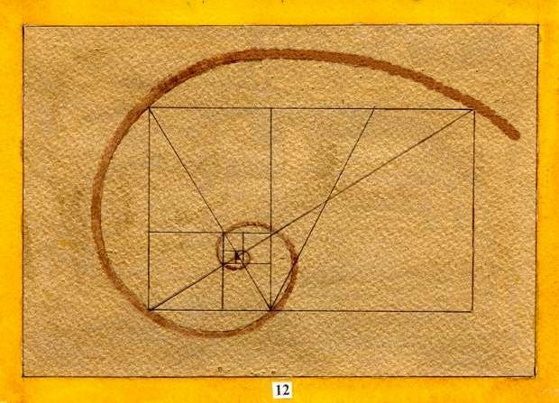

Every Sacred Presentation Contains the Aesthetic

The elegance and beauty concealed in the Golden Section is demonstrated in the shape of a Spiral that is formed by drawing a line over the corners of the figure in progressively smaller curves.

13.THE MEASURES OF THE PENTAGRAM IN THE GOLDEN SECTION

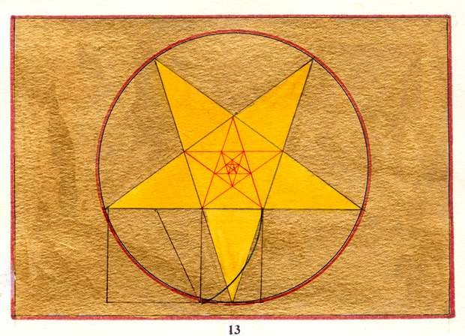

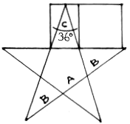
Fig. 13

The Construction of a Unique Figure

The proportions of the Pentagram are contained in the measures of the Golden Section. If A) is the basis for one point of the Pentagram, and B) is the length of its sides, C) the angle of 36 is exactly the measure of one of its points.

14.THE PENTAGRAM AS A SYM BOL OF SPIRITUALISATION

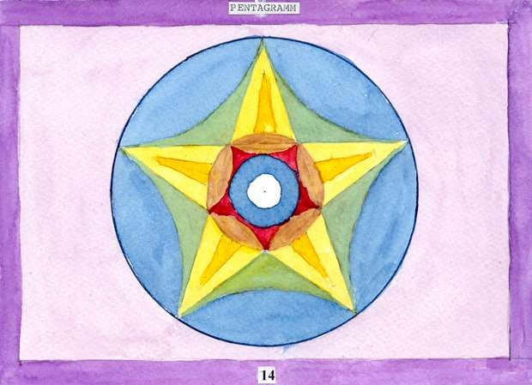

Fig. 14

Analysis of its Composition

Taken as 1 + 4, the one is the dot in the centre of the Square. This symbolises spirit in the middle of matter. The one tends to DEMATERIALISE the material aspect of the Square by its potency to form unity.

If one regards the five as 2 + 3, the relation to the Triangle and its harmonising effect on the tension of duality becomes apparent. In the lower corners of the Triangle duality is likewise constellated. This, however, is drawn towards its apex by its unifying tendency (compare to Fig. 6).

This process also applies to the line of duality below it.

The Symbolic Meaning of the Pentagram

There emerges a picture of the QUINTESSENCE where by all five points of the Pentagram correspond to spiritualisation of the primal ONE. The unity of the Triangle above the two indicates the primacy of the Spirit.

The Pentagram results from the proportions of the Golden Section, giving it its fascination and preciousness. The Pentagram symbolises Venus, love, beauty, coupling, mankind and the Holy Ghost. The tendency towards unification creates the power of sexuality as a longing in all beings and a yearning for the Light of the ONE in Kundalini.

The Sacred Centre

The circular variant in Fig. 14 shows a central area, which, as in the case of the
Octagon and Nonagon, constitutes an opening to the presence of the ONE.

If the Pentagram is regarded as a presentation of the five elements, ether being the least dense element may be found at the highest point.

Concepts from the ‘Middle Ages’

The Pentagram became known as a charm against witches and devils and was used as an amulet.

15.ANOTHER FORM OF THE PENTAGRAM Fig. 15

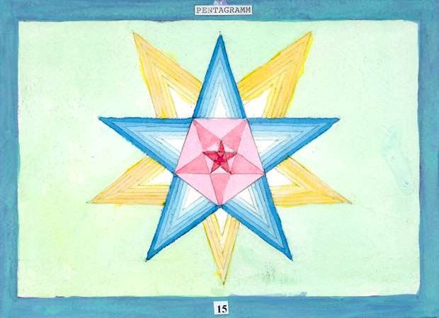

Significance

This presentation shows the representation of the reduction, respectively enlargement of Pentagrams into infinity. The inversion, respectively expansion of the figure is in this case not a mirror image, but represents a reversal of the direction it develops.
This refers to the tendency towards materia lisation (see Fig. 8) in the numbers up to four and the dematerialization in the figures five to nine.

In the case of the figures belonging to the numbers five to nine, it appears the graphical presentation of the so-called ‘Gon’ (Hexagon, Pentagon, Heptagon, Octagon, Nonagon). This ‘Gon’ represents an image that can be enlarged or made smaller into infinity. Because of this the ‘Gon’ shows a relationship to the infinity of the primal ONE and has a sacred value. The exceptions here are the Hexagon and the Octagon with predominant dualistic tendencies.

PRINCIPLES: GOLDEN SECTION, DEMATERIALIZATION, QUINTESSENCE.

16.THE CONSTRUCTION OF THE CIRCLE Fig. 16

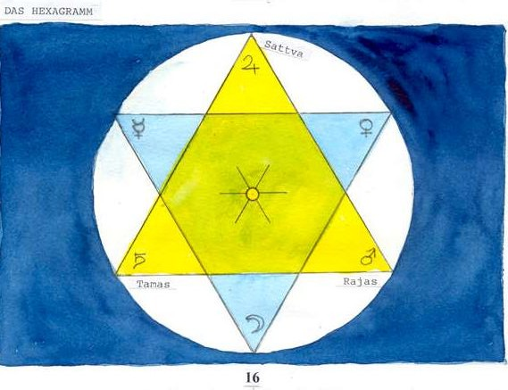

How Geometry Can Depict Creation

At the beginning of creation, there IS the infinitely small, still and dimensionless point of the primal ONE. In that emerges the impulse to expand into a straight line. This line emerges as a RADIUS of the first CIRCLE that consists of a round line of an infinite number of points.

The Circle and the Emergence of the Hexagram

Regard the metal point of a compass as still and having affinity to the primal ONE and, the carbon point as related to multiplicity. Now, when the length of the radius is marked out on the circumference, this gives exactly six sections of equal length. Thus one gets three points on this circumference related to unity and three to duality. By connecting the three respective points with each other one creates two overlapping Triangles, one standing, one inverted.

The Circle of Opposites

These two Triangles form a duality. The standing one can be regarded as i.e. the light Yang, with an affinity to the primal ONE, the inverted one as the dark Yin. This presentation of the two Triangles is called the Seal of Solomon. In this duality the lower one is a reflection of the upper one.

The Circle and the two Triangles have a common centre because the ONE is present in all entities.

The Ancient Gods Characterise the Points of the Hexagram

The male planets are situated in the upper Triangle. At the apex is Jupiter, corresponding to the Greek Zeus. Zeus is the ruler of the Greek gods, always in pursuit of the largest and richest and striving for expansion. Mars is the active, extroverted and dynamic Warlord. Saturn, ruler of time, is introverted, hard and stubborn.

The mother goddess is located at the lowest point in the introverted Triangle. She is mother earth and the caring Moon. She is sensitive, emotional and a nourishing deity who furthers growth. Venus is goddess of love, harmony and beauty. Mercury is the messenger of the gods and, is neutral, unstable and intellectual.

The Sun has always represented the divine principle, in this case the ONE,
symbolised by the centre, light, life, vitality and the highest authority. The Sun is in a
directing and leading position in every hierarchy.

There are two polarities of energy: that of Mars and Venus and, that of Saturn and Mercury. The later polarity becomes evident because of Mercury’s relation to the metal; mercury, with its total instability and reaction to temperatures in its environment. As a messenger of the gods Mercury can descend from the Olympiad right into the underworld. With his caduceus he is also a symbol of transformation.

PRINCIPLE: ORDER

17.IN THE HEXAGRAM THERE IS UNITY OF DUALITY Fig. 17

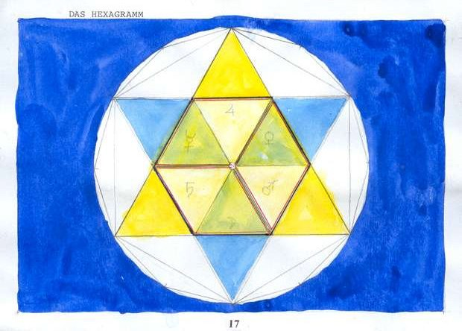

The Complexity of Operating Influences

In the middle of the two overlapping Triangles emerges a Hexagon. The Triangles outside are projected inwards because of the principle of reflection. This is a projection of the absolute, of the cosmic Being onto the relative differentiation within the Hexagon.

The Hexagon consists of two sets of six lines of relationship that signifies harmony between the light and dark Triangles. The external cosmic lines do not touch each other, but those within the Hexagon form a unity of relationships together.

A Triangle, by its nature, causes differentiation and this causes a mutual approach in the six Triangles of the Hexagon. Out of this two different combinations result, according either to the principle of unity, or of duality.

The principle of unity: in this case the physical forms, which are projections of the cosmic ones, draw in mutual harmony to the centre and dissolve into the primal ONE.

The principle of duality: in this case two pairs of dark and light Triangles emerge, which together strive to unite.

Cosmic Influences Shown Geometrically

Hereby the astrological archetypes can be taken into consideration in the order to differentiate between the pairs.

In this manner the pair Venus and Mars suggests male and female, love and hate, art and work etc. The pair, Moon and Saturn, suggests youth and old age, birth and
death, abundance and want, etc. Mercury and Jupiter bring the aspects of intellect and
wisdom, detail and totality, small and large etc.

The inner structure of the Hexagram shows the world in its diversity. The polarities are projections of the eternal, metaphysical and archetypal values of the two primal Triangles that represent the level of Being. Those Triangles which are formed outside the inner Hexagon suggest: the Fire Triangle - in the apex; Light, in the right corner; Love, and in the left corner; Consciousness. The Water Triangle – at the lower point; Life and Fertility, in the right corner; Agape and Beauty, in the left corner; Truth and Transformation.

In the middle of the Hexagon, as mutated, a CUBE emerges. It is recognisable as a three-dimensional perspective of the Hexahedron.

PRINCIPLE: CUBE

18.THE HEPTAGRAM Fig. 18

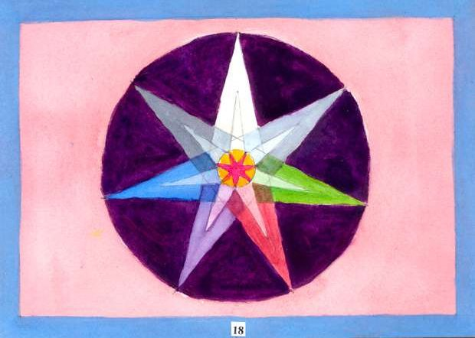

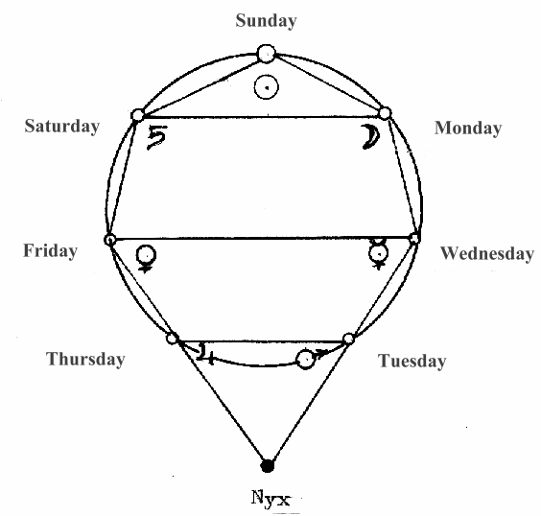
Contemplating the Composition

Considering it as composed of 1 + 6, there emerges the area where the Triangles of duality, in the hexagram, superimpose on each other. This combination with the

central One suggests creativity and inspiration, prerequisites for the expression of beauty, harmony and style in life as well as in art. This influence can also be experienced in the ardour of sexual union, and give rise to the formation of the new, leading to conception and birth.

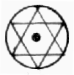
Regarded as the 2 + 5, we find duality of the Two influenced by the sacred qualities of the Pentagram. This causes a tendency to harmonisation between the two poles of duality. On the other hand, the effect of duality on the Pentagram causes tension within it and to an energetic tensing of its seven points. The mutual influence causes a tendency to coincide, resulting in an integration of its qualities.

Regarded as a Triangle over a Square, resulting in 3 + 4, the Triangle causes a spiritualisation and at the same time the intellectual and spiritual sides of the Triangle receive a solid basis in reality. All this results in a consolidation and at the same time dematerialization.

Because of the dissolution of the world and the general consolidation and sublimation, the SPIRITUALISATION of the material aspects of things is achieved. The notion of the spiritualisation of existence is founded on the ever-presence and the almightiness of God, who causes the impulse to ‘return to Unity’ in all creation.

Tensions are being harmonised, the darkness penetrated by the Light, hatred, which destroys the subtle part of our being, is transformed to mildness. The relinquishment of all attachment is furthered and the bound ego liberated.

The qualities of the seven individual points of the Heptagram can be understood by referring them to the symbolism of the mythical gods of the solar system, the names of whom have been associated with the days of the week.

Naturally the Sun would be at the zenith, flanked by the Moon and Saturn, creating a Triangle of the most celestial bodies. The remaining four planets form a Trapezoid together.

When a line is drawn parallel to the base in a unilateral Triangle, a Trapezoid appears suggesting a Triangle (by prolonging its sides upwards). In the present instance the apex of the Triangle would reach beyond this schematic system, right into the archetype of darkness, Nyx. On the upper level of the Tapezoid we find Mercury and Venus, those planets which circulate closer to the Sun than we do on Earth. Mars and Jupiter circulate further away.

PRINCIPLES: SPIRITUALISATION, TRAPEZOID, NYX.

19.THE OCTAGRAM Fig. 19

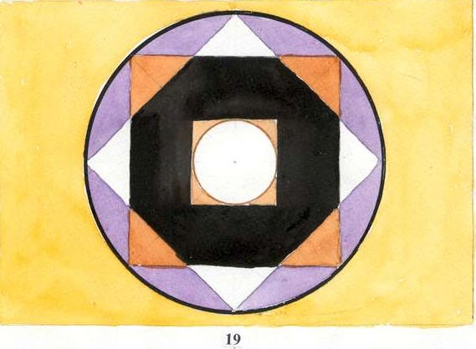

A Picture of Contrast

A static and a dynamic square overlap each other. The dynamic one is white and has a large round centre, the diameter of which equals the length of the base of the outer Triangles. The static one is yellow, the colour of the earth. The area where the squares are superimposed is black, as a contrast to the sun disk. A third square becomes apparent in the middle of the Octagram, it is a light source and denotes the presence of the Primal ONE.

The yellow square of material existence is in the radius of the white ones action, and
is being illuminated by the Light and penetrated by its energy. This causes a symbolic polarity to emerge of static and dynamic, dark and light, death and life. The Light of the ONE withdraws life back into itself, the remaining body decomposes into mere matter.

Composition of the Basic Influences

The combination of 1 + 7 results in a positive aspect of the Octagram because it is composed of uneven numbers. The tendency for dematerialization and the spiritual influence of the Heptagram combine here with the principle of Being. The ONE, as luminous source, bestows positive qualities to the figure. An impulse to TRANSFORM and merge into ONE is caused by the contrasting qualities of dissolving and solidifying.

The numbers 2 + 6 dually exist as two opposing units on the one hand, and, two Triangles on the other. Here antithesis is apparent. The interchange between the two parts is interrupted causing weakening and tension. The male/female symbolism of the Hexagram in connection with the qualities of transformation of the Octogram points to the connection of life, eros and death.

The numbers 3 + 5 mix the qualities of communication and harmony of the Triangle with the sacred, the uniqueness and power of dematerialization of the Pentagram.

This is a clear indication of the presence of death in the body, the tendency of which has already been noted to be part of the over all meaning of the Octagon. This transformation happens through the tendency of the Triangle to split, parting spirit and matter, whereas the sacred qualities of the Pentagram can cause the Light of the inner Circle.

The phenomenon of the 4 + 4 (2 + 2 = 4 and 4 + 4 = 8) means an increase in even numbers. This causes a maximum solidification, an extreme of polarisation and the greatest opposition. In the Octagram white and black, light and darkness, life and death, are jointly present. The Octagram contains a maximum of contradictions, increased to the extreme by the doubling of the four.

Tensions and crisis, transformations and change are constellated, or some kind of finality. Apart from a fall out of rigidity there is an opening to the world of Light.

PRINCIPLES: TRANSFORMATION

20.THE NONAGRAM Fig. 20

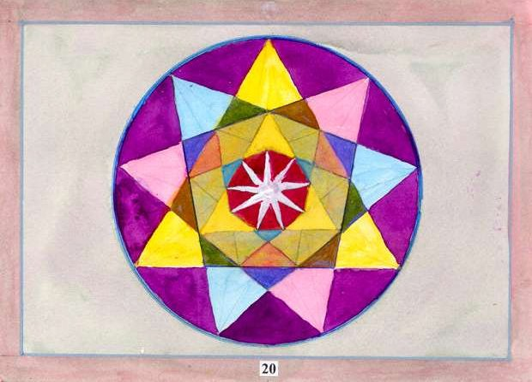

The Process of Unification is Accomplished

Taken as a combination of three Triangles, this presents a manifestation of their qualities of differentiation and of plurality, demonstrated here in their multicolour and diverse sizes. The upright Triangle in the centre is yellow symbolising the ONE. The two flanking Triangles constitute a duality and are tinted with the primary colours, red and blue. In this context the red has a dynamic quality, the blue a static one. A
tension is present between them.

Taken as a trinity they signify:

Colour Archetypal plane Sentient beings

Yellow Spirituality Spirit Red Vibrations Mind Blue Matter Body What this Means for the Quality of Life

The tension of duality is released by the yellow Triangle in the Nonagram and by the white Nonagon in the centre (see Fig. 21). In the central area of the Nonagon a zone of INTEGRATION appears where the three colours overlap.

On the neutral background Triangles appear of differing qualities. In the area where the background is empty and undefined a zone appears, which on the archetypal level may be defined as PRIMA MATERIA, and on the human level as the UNCONSCIOUS.

Exactly as the doubling of the two indicates negative qualities, the threefold appearance of the three enhances beneficial effects. Being composed of three Triangles the Nonagram represents the principle of the Triangle in its highest form.

PRINCIPLES: INTEGRATION, PRIMA MATERIA, UNCONSCIOUS.

21.THE ONE MEANS TOTALITY Fig. 21

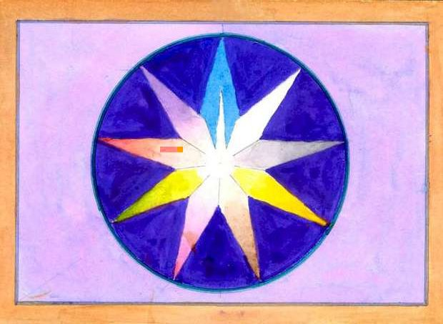

The Return to the Primal ONE

With reaching the number nine, in the case of the primal numbers, the principle of unification is achieved. Through the other numbers this goal is enriched with a multitude of qualities. In order to understand this development one should realise that all numbers consist of a multiple of one.

The whole process of the ‘return to the ONE’ is reflected in the evolution of life on
the earth, from the first living cells, to the appearance of vegetation, animals and man,
evolving in ever higher stages of existence.

In this development, humankind has been enlarging the capacity of its brain, thus creating an expanding consciousness. Imbedded in sections of the human brain there exists, presently unused, capacities which may enable higher states of awareness. This has been apparent in a few individuals over the ages, and, has bestowed upon us the founders of the great religions, mystics, and individuals of genius in the arts and sciences.

Today there are more and more cases of that which is known in the east as the awakening of Kundalini. An American medical doctor informed the author that she had seen a thousand cases of awakened Kundalini in her practice.

At the beginning of this discourse, it is stated that consciousness is one of the three attributes of the ONE. Kundalini (when healthy) accelerates the process of expanding consciousness and a return to the Source.

In Hindu tradition this impulse to return to the Source is described as a white snake, lying asleep, curled up in the lowest chakra. When the time is ripe, she uncurls and rises in the spine in order to unite with her spouse, the supreme Lord Shiva, at the crown chakra. This serpent is simultaneously the Shakti, the all-creative half of Shiva, who abides aloof in the eternal bliss of supreme meditation.

Esoteric Mathematics

In order to get to grips with the qualities that make up the Nonagram it is helpful to resort to the esoteric way of counting (Qabbalistic reduction). This method consists of reducing all numbers larger than ten into those of one digit. This is achieved by adding the individual numbers together until a single digit result i.e. 652 (6 + 5 + 2 =
13 then 1 + 3 = 4) = 4.
Using this method, the particularity of the number nine is that if it is multiplied with another number the result is always nine i.e. 2106 = 2 + 1 + 6 = 9. If one adds together those numbers from 1 to 8, the outcome is 36 = 9. If one multiplies the numbers from 1 to 8 with each other the outcome is 40320 = 9.
Taken symbolically, this means that the Nine has the capacity to absorb all single
digit numbers into itself. In this instance this means that, through the existing principle of unification in all manifestation, all numbers, one to eight, form a totality. These numbers, with their specific qualities, have enriched nine, and together with it form a Unit. In order to understand this better, compare it with the development towards Unity illustrated with three Circles (Fig. A to E, page 16-20). It is because of this unity, within the symbol of the single-digit numbers, that nine has become an image of ONE.
The zero cannot be absorbed, and forms together with the nine (which has become one) the number ten. This is possible because of the zero’s potency, which enriches nine by tenfold.
Principally, the whole world of duality is in the process of becoming one, of unifying. Creation is total and undivided.
‘And if we are only one grain of sand on the beaches of eternity, the Universe would be incomplete if even one of these grains would fail.’

1

1 1

1 1 1

1 1 1 1

1 1 1 1 1 1 1 1 1 1 1 ALL IS ONE 1 1 1 1 1 1 1 1 1 1 1

1 1

